Why we need Kubernetes:

1) With the help of docker we can convert manual deployment instructions to platform independent docker image. Docker offers standard packaging format for Application.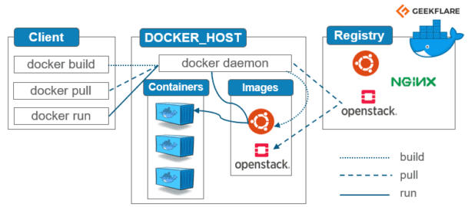

2) Problem with docker: Container is limited only to one host, even docker compose would be working only on 1 host. So, before we think to use container in production, we need to think for below points-

* [Container scheduling] which container to run where?
* [Networking issue] How container would be communicating.
* [High availability]
* [Auto scaling]
* [Load balancing]
* [service discovery]
* [self-healing]

Now, to solve above problem we need container management.

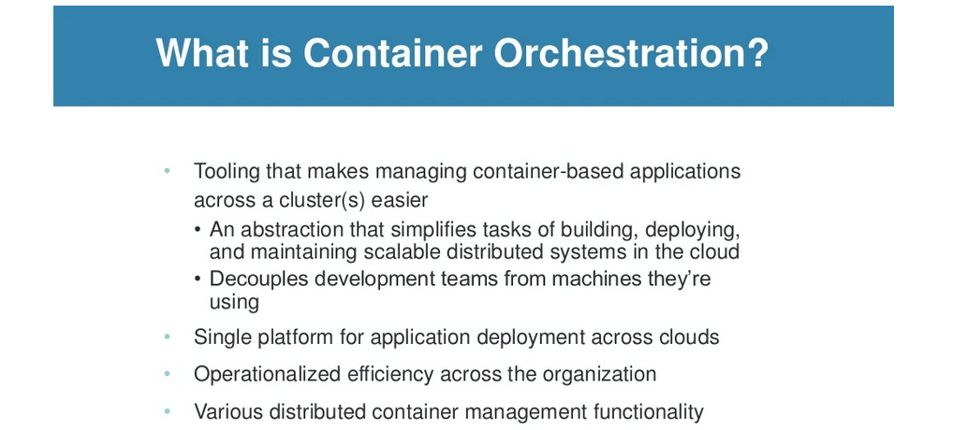

Example: Docker swarm, K8s, Borq and Omega.

Now, to address above problem docker introduce docker swarm, but it was not that much successful.

Kubernetes history: Container was not a new concept for google, they are using container from very long time. [in year 2011]

Docker: 2013, Docker swarm: 2016 and Kubernetes: 2014

Before introducing K8s into market, Google was having approx. 15 yrs. experience in container management they were using Borg/Omega.

Let’s proceed to understand K8s architecture and installation.

Kubernetes works on master/slave(s) setup.The Master has a number of independent jobs that need to be executed. It sends separate jobs to all its Slaves. The slave processes the job and sends back the results to the Master. The Master integrates the results in its database and feeds the Client more data.

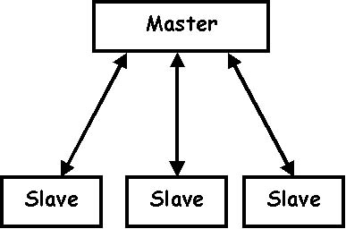

A cluster is a set of [nodes](https://kubernetes.io/docs/concepts/architecture/nodes/) (physical or virtual machines) running Kubernetes agents, managed by the [control plane](https://kubernetes.io/docs/reference/glossary/?all=true#term-control-plane). Kubernetes v1.25 supports clusters with up to 5000 nodes. More specifically, Kubernetes is designed to accommodate configurations that meet all of the following criteria:

Support Link: <https://kubernetes.io/docs/setup/best-practices/cluster-large/>

* No more than 110 pods per node
* No more than 5000 nodes
* No more than 150000 total pods
* No more than 300000 total containers